DEPLOYMENT PROCEDURE
Employer QC and Staging server

- My eclipse server settings

- Go to My Eclipse and click on CVS Repositories.

- QC: Go to “Branch” and select “tjemployer_FUJI” folder.
STAGING: Go to “Head” section and select tjemployer folder.

- Expand respective folder and right click on that and select ‘Check Out As’

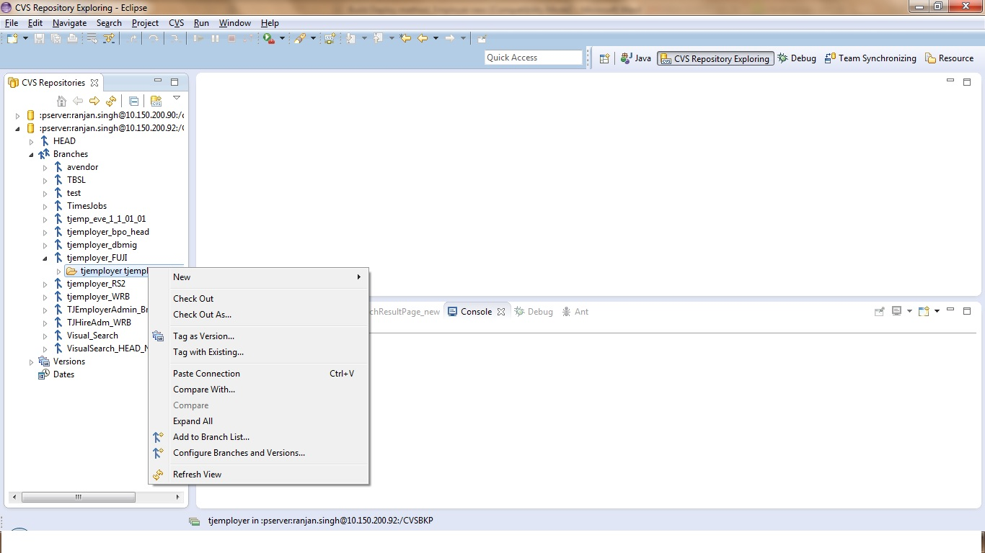

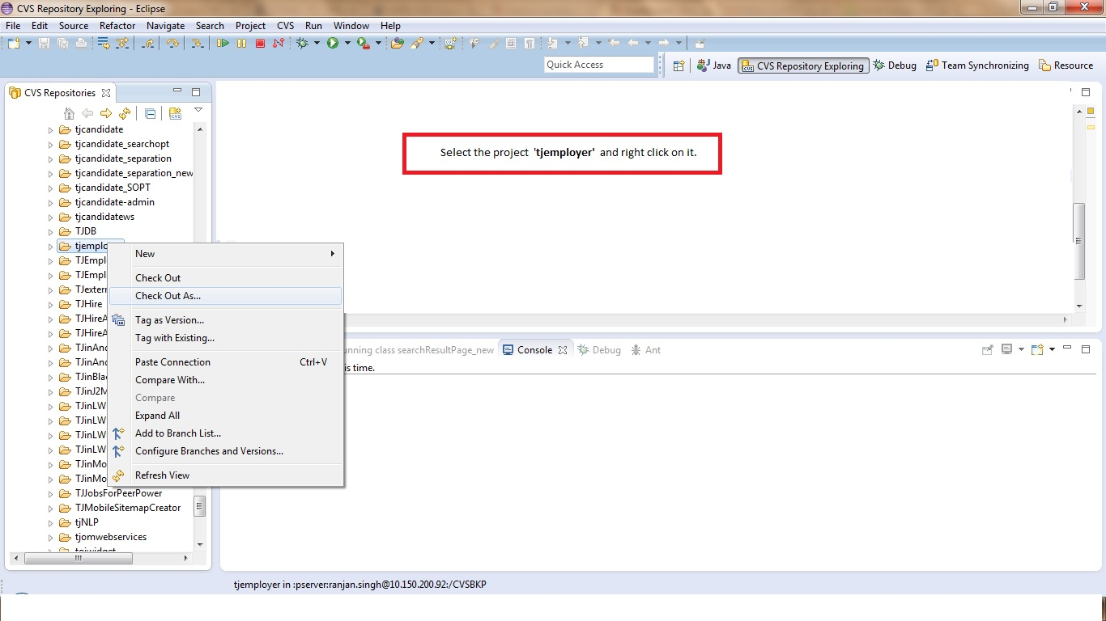
2) Give the name of the project and click on ‘Next’ till ‘finish’ button. Project will get check-out in your eclipse.

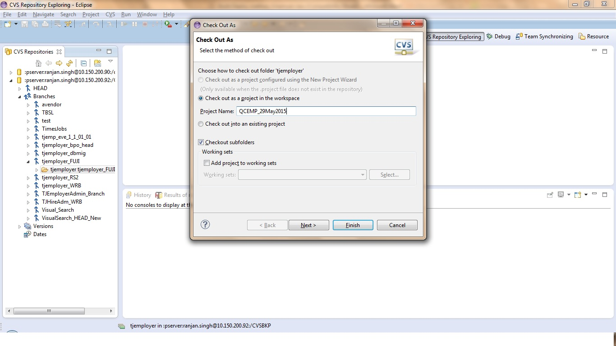

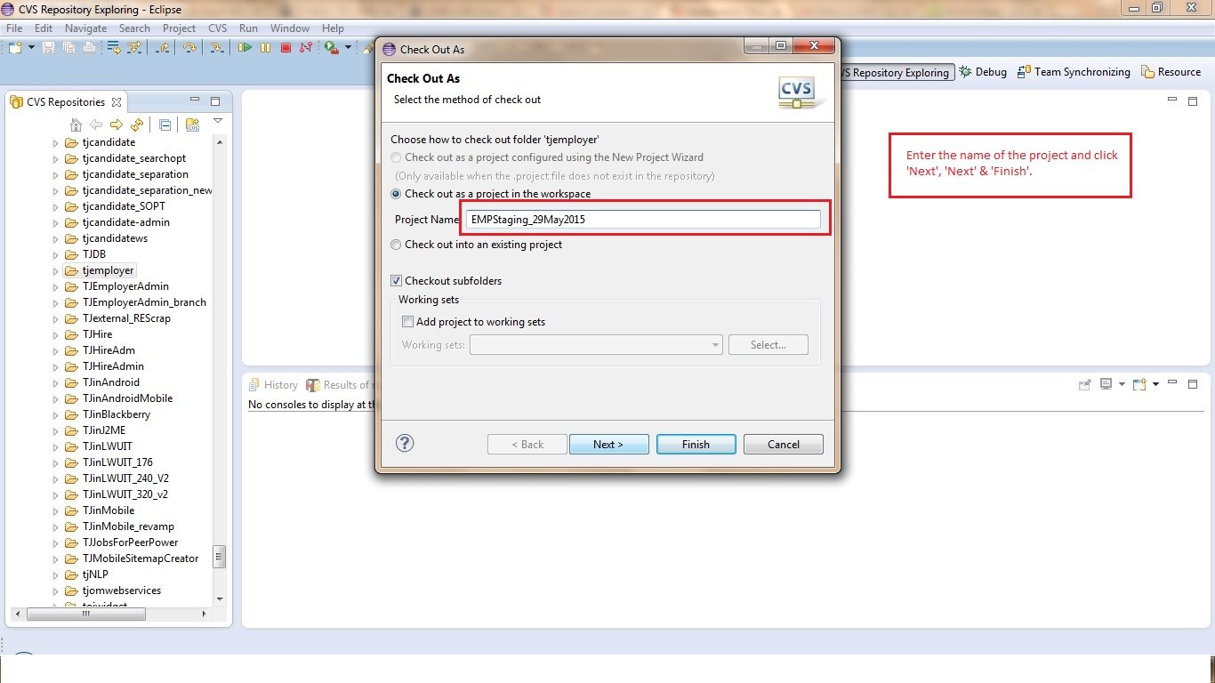

3) Checkout Project will appear like:

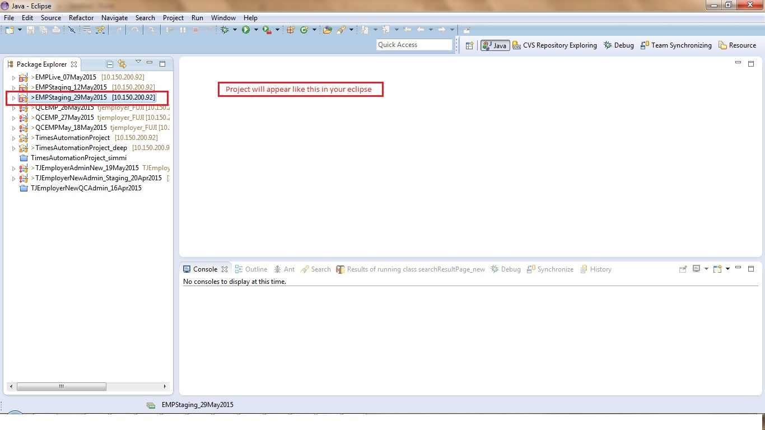

4) After tag gets copied successfully on local machine, press “SHIFT+CTRL+R” and enter “searchconfig.xml”
Select the file from respective project (QC or Staging) that you have checked-out

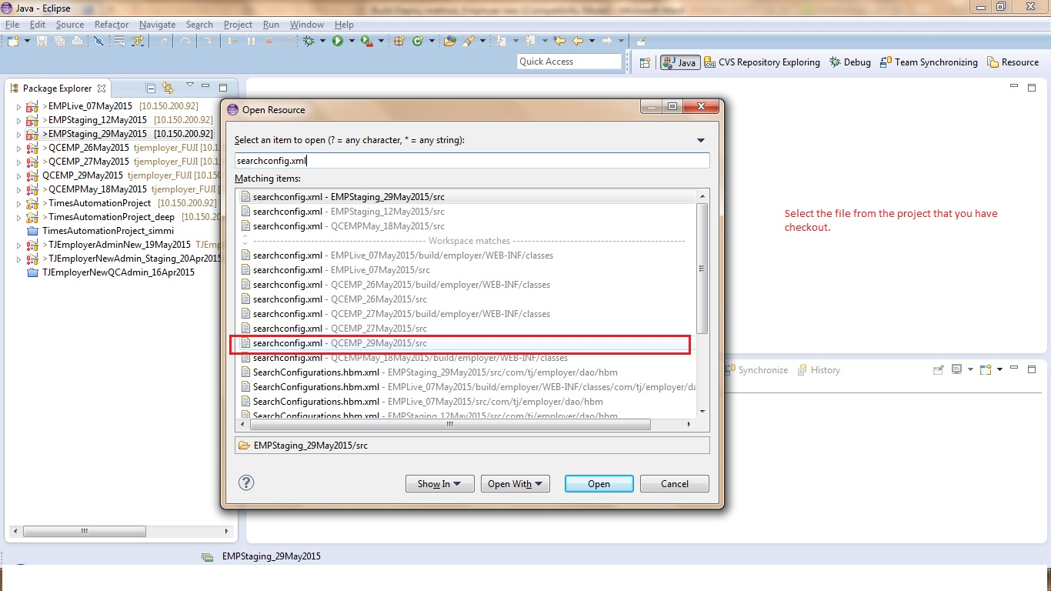

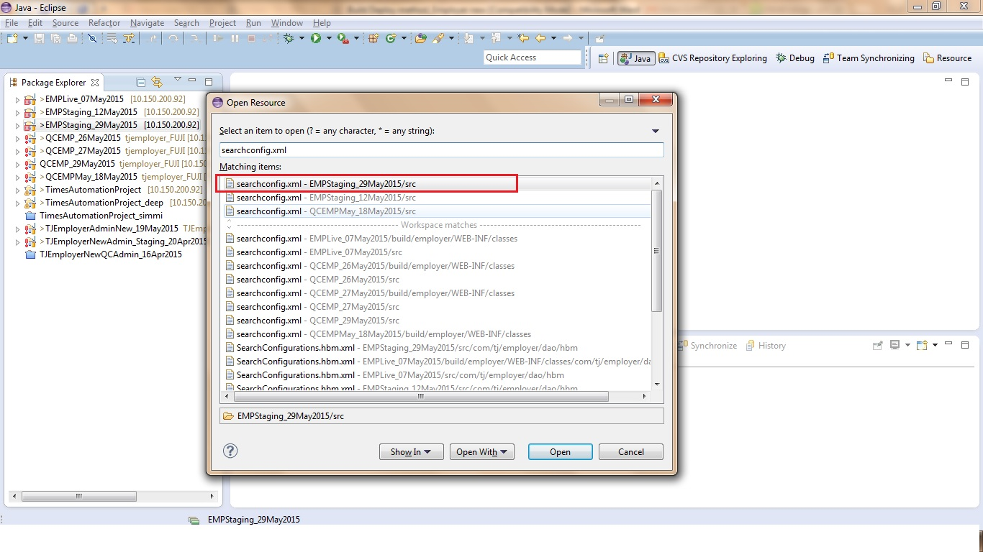

4. (i) No need to perform any change in this file for QC Server.
(ii) Change the following IP addresses in the file at staging server

→ http://192.168.206.35/Hire/resume/select to http://115.112.206.83:8081/Hire/resume/select
→ http://192.168.206.34/Hire/job/select to http:// 115.112.206.82/Hire/job/select
→ http://192.168.206.34/Hire/folderSearch/select to http:// 115.112.206.82/Hire/folderSearch/select
→ http://192.168.206.34/Hire/resume/select to http:// 115.112.206.83:8081/Hire/resume/select
→ http://192.168.206.34/Hire/ivr-new/select to http:// 115.112.206.83:8081/Hire/resume/select
→ http://115.112.206.22/VisualSearch/WikiLink/select to http:// 115.112.206.83:8081/VisualSearch/WikiLink/select

5) Press save icon

6) Again press “SHIFT+CTRL+R” and open “ConfigConstant.java” select the file from respective project (QC or Staging) that you have checked-out. Proceed as per the instructions given below in the doc. For ConfigConstant.java

Code changes to be done in ConfigConstant.java file path (src/com/tj/employer/utils/):

(a)

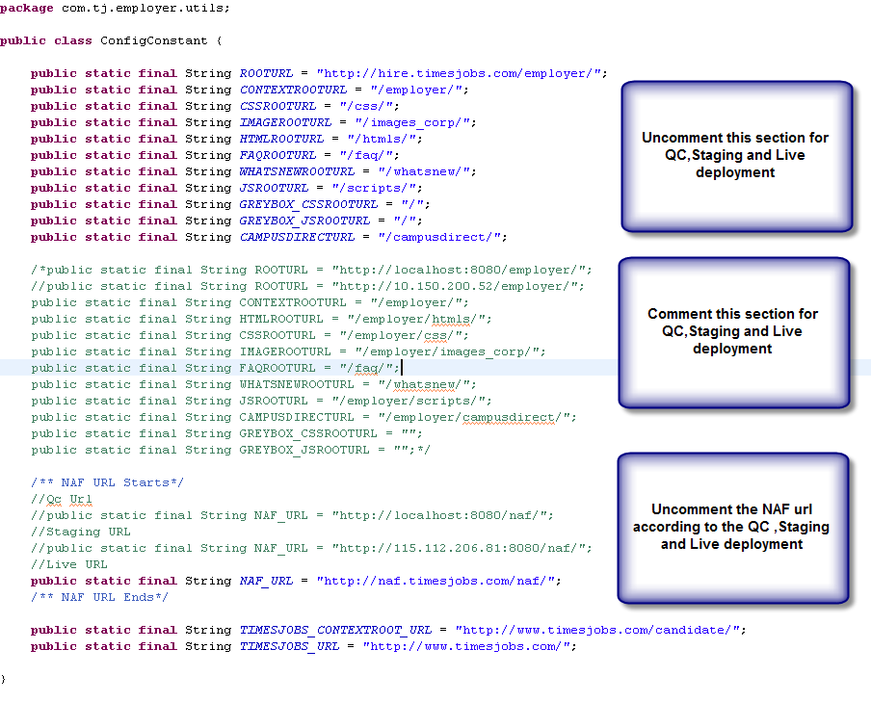
b) Change the following values too:
For QC

public static final String ROOTURL = "http://qchire.timesjobs.com/employer/";
public static final String HIRE_BASE_URL = "http://qchire.timesjobs.com";

public static final String TIMESJOBS_CONTEXTROOT_URL = "http://candqc.timesjobs.com/candidate/";
public static final String TIMESJOBS_URL = "http://candqc.timesjobs.com/";
For Staging:
public static final String ROOTURL = "http://115.112.206.82/employer/";
public static final String HIRE_BASE_URL = "http://115.112.206.82";

public static final String TIMESJOBS_CONTEXTROOT_URL = "http://candstaging.timesjobs.com/candidate/";
public static final String TIMESJOBS_URL = "http://candstaging.timesjobs.com/"
8. Click on the save icon
9.
(a) For QC
Press “SHIFT+CTRL+R” and enter “applicationContext.xml” and proceed as per the instructions given below in the doc for applicationContext.xml

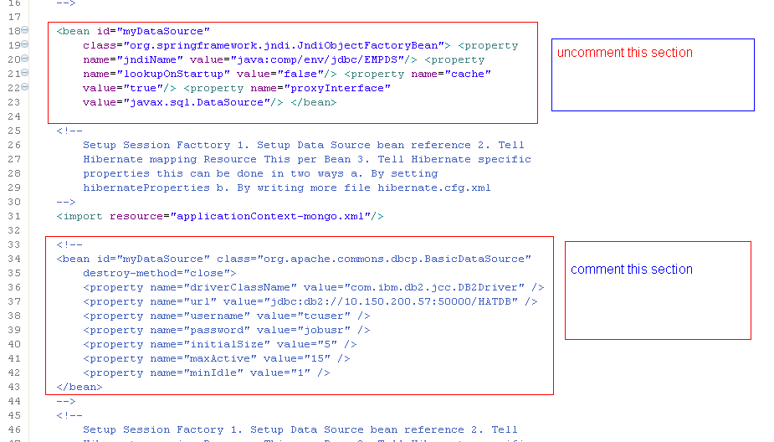
& Click on the save icon

For staging:
b) Press “SHIFT+CTRL+R” and enter “applicationContext-mongo.xml” and select the file.
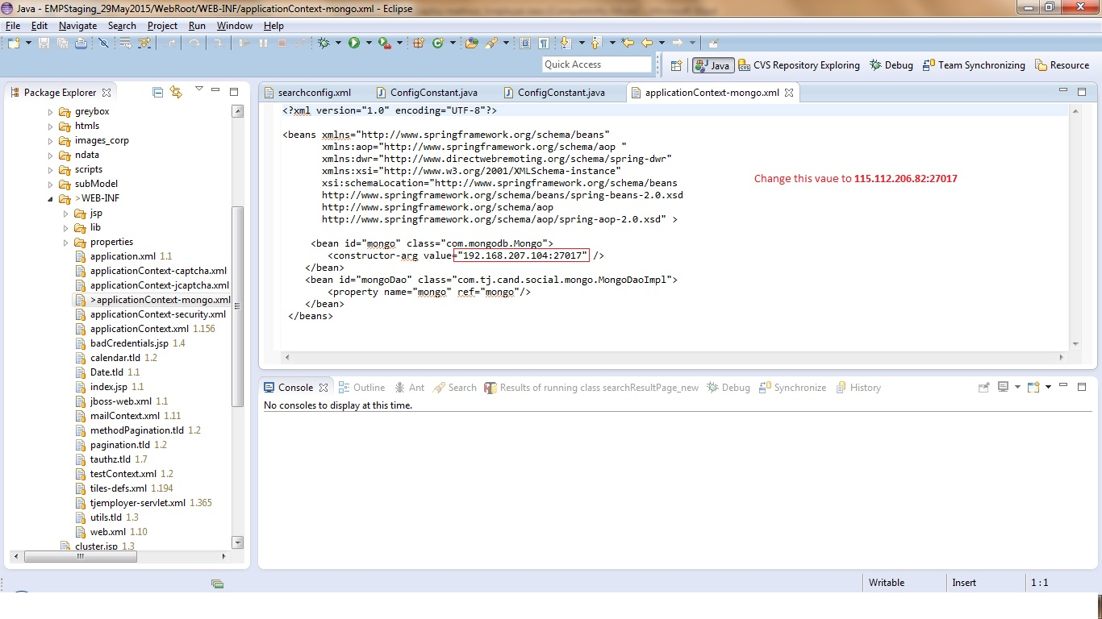
To create a build through Eclipse
- After above mentioned activities time is to create the build for the deployment
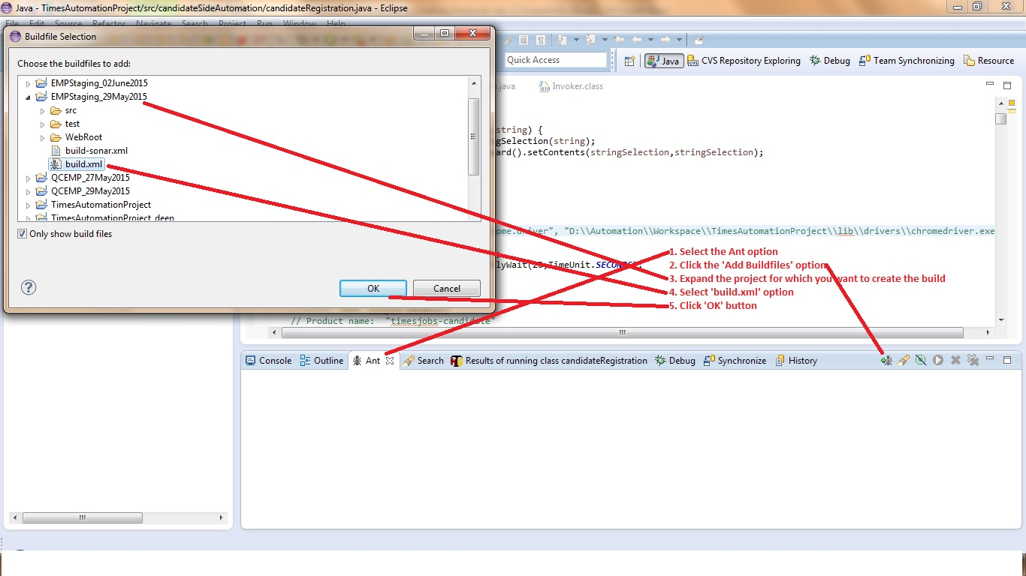
- Expand the Project exist under Ant tab and double click on the build[default]
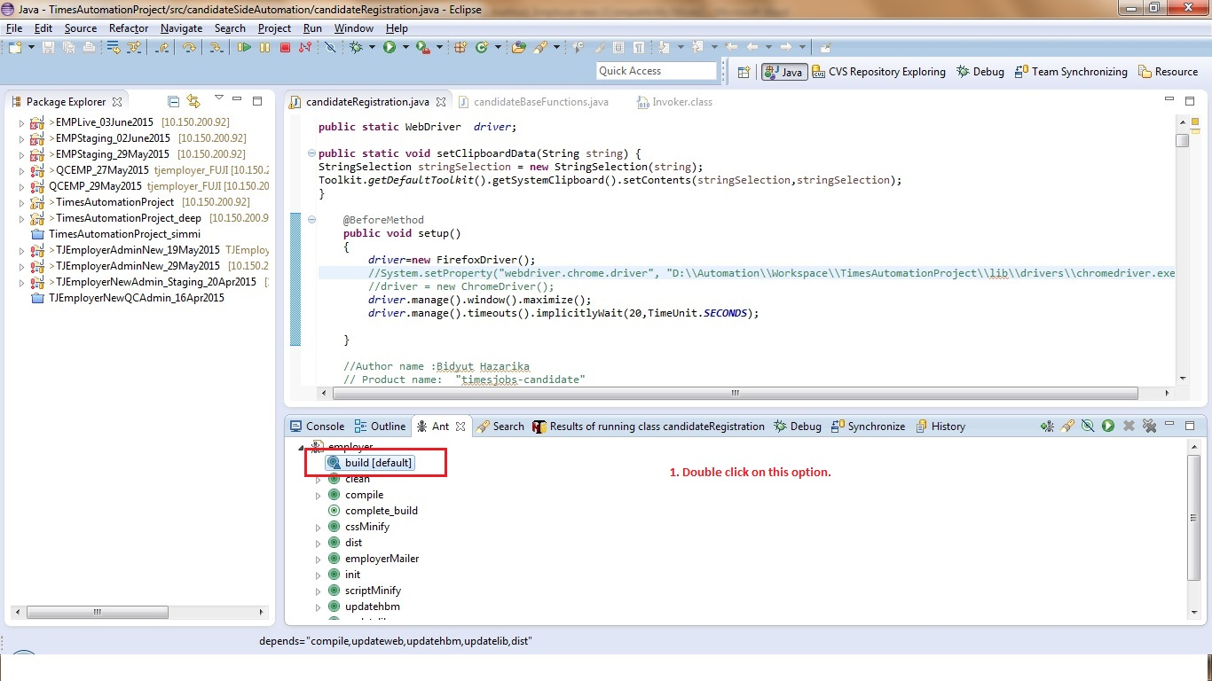
- After successful creation of the build following instruction will appear in the console
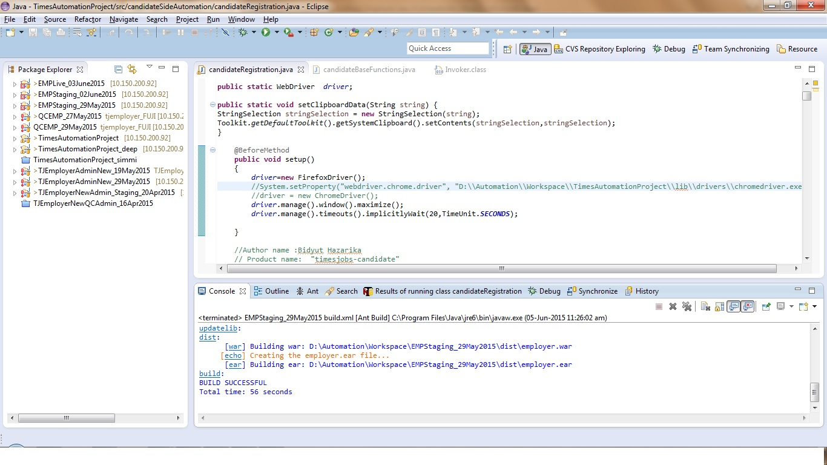

Build deployment on Server
1. Once build is created successfully, open WinSCP and enter URL of the server on which user wants to deploy the tag
Enter: - Username / Password and press “Login”
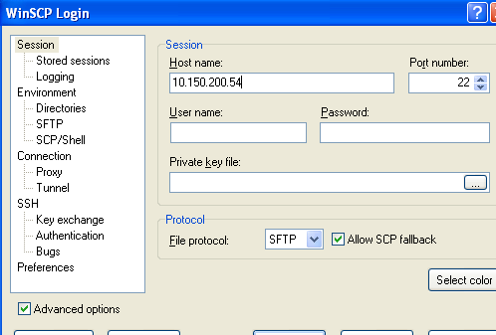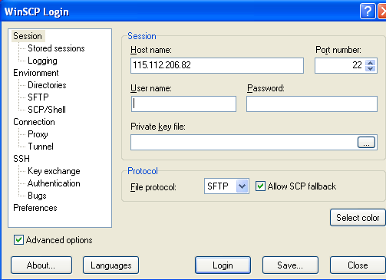
2. Enter path: - /opt/tomcat/webapps/ employer appearing and click ok
3. Open the employer folder in WinSCP
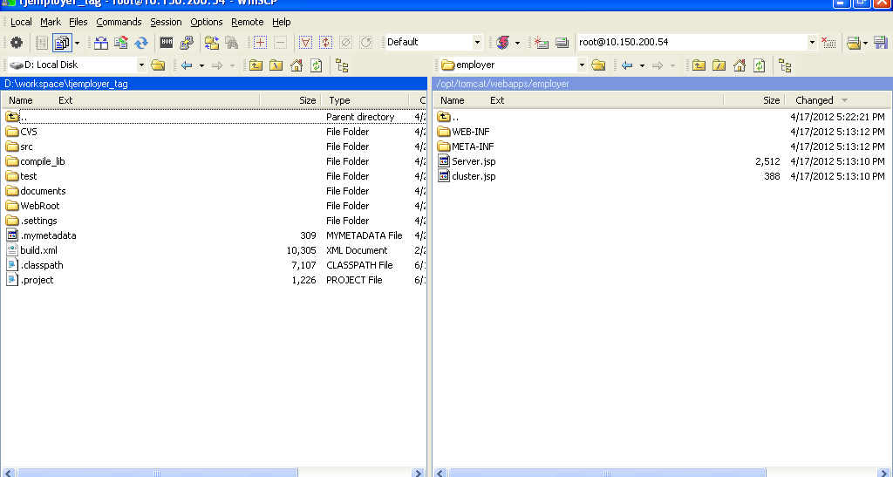
4. Open putty enter host name that is the URL for QC: 10.150.200.54 and for Staging: 115.112.206.82 (employer staging server) and click Open button
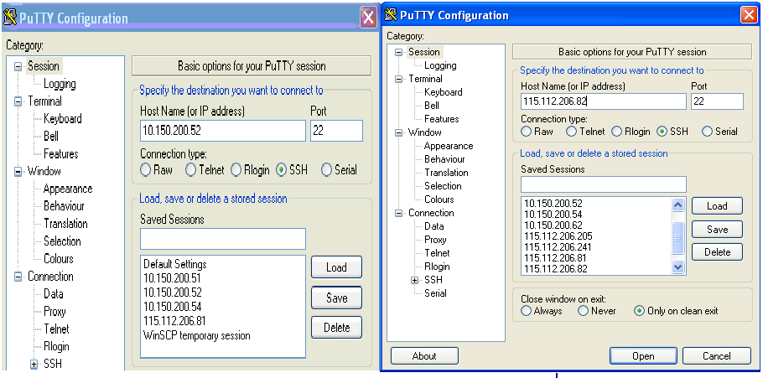
- Enter username and password in putty
- Go to path cd /opt/tomcat/webapps/
- To remove the current folder enter command: rm –rf employer
- To create new folder: - “mkdir employer”
- Enter command cd employer in putty to go into employer folder
- Go to WINSCP and open the newly created “employer” folder from the location where project exist
- In left pane click the path to go to workspace folder in local where the build is created and war file present
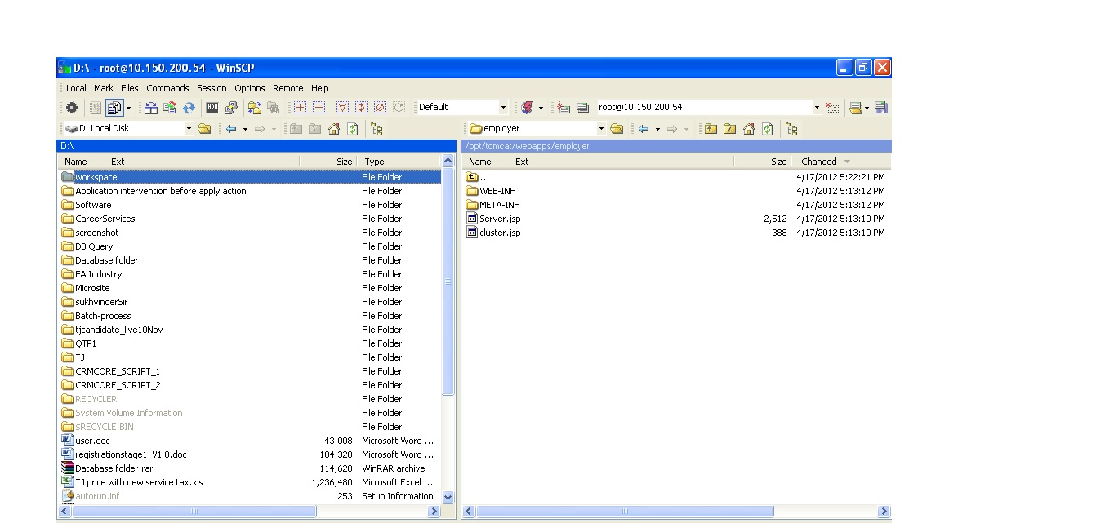
- Open workspace and select the tag/project name
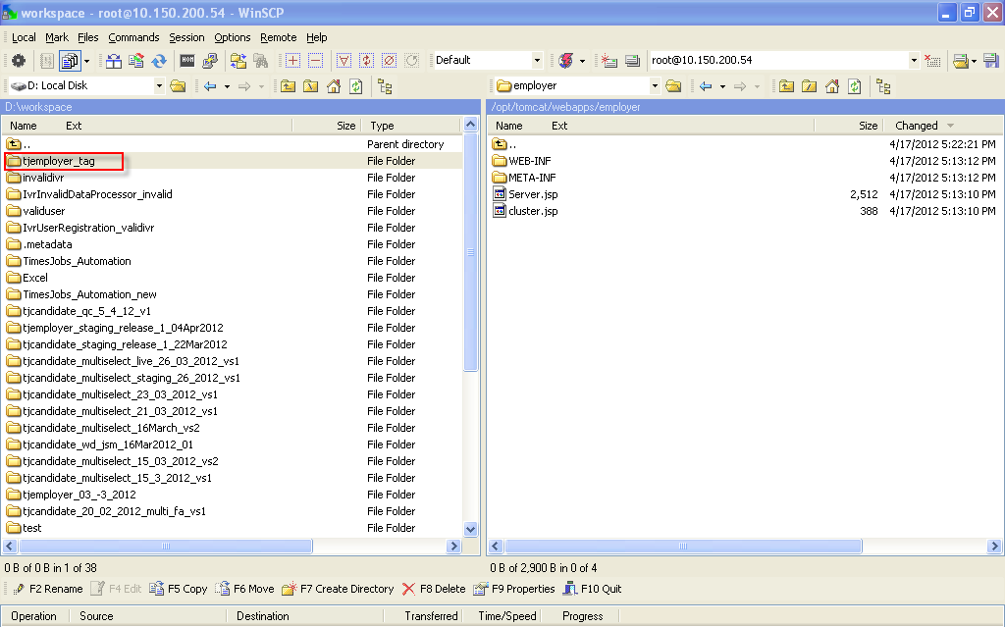
13. Select folder dist present in the Tag/project folder
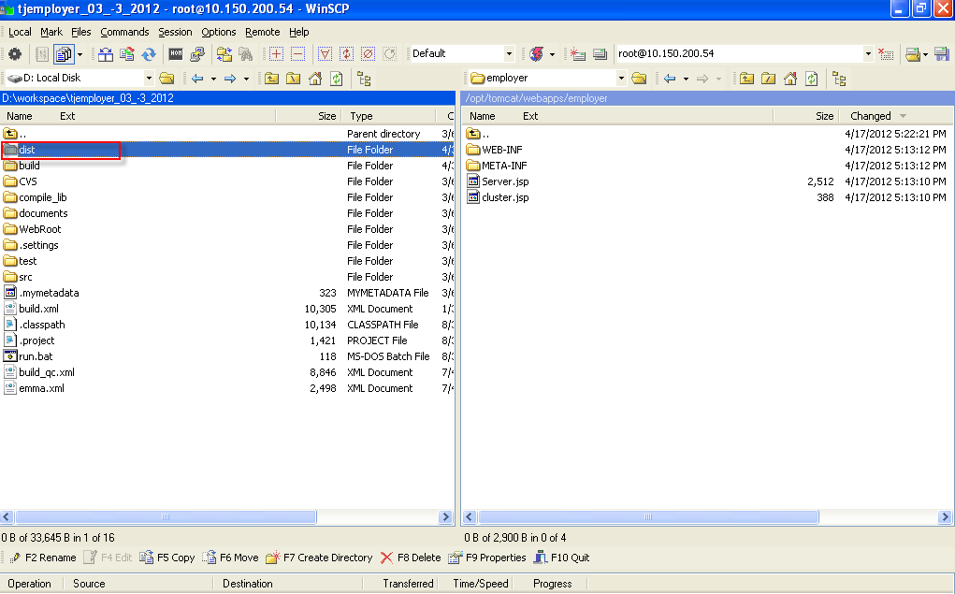
14. Drag and drop file having extension “.war” from left to right pane of WINSCP window
15. Click on “Copy” button
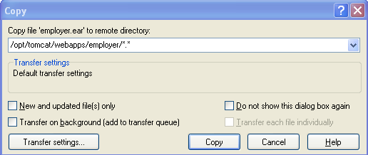
16. Copy window should appear
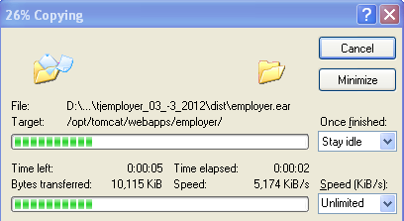
17. Once war file is copied go back to Putty and in order to extract the Zip folder enter command jar -xvf employer. war
18. to remove folder Zip folder enter”rm employer. war”
19. Press “y” and Enter
20. To shutdown the tomcat server enter command “/opt/tomcat/bin/shutdown.sh”
21. To check the process running, enter the command “ps -ef | grep tomcat “
22. If process running then:-
kill -9 25239---- > Kill Process Running by specifying the Process ID
23. To start the tomcat server, enter the command “/opt/tomcat/bin/startup.sh”
24. To verify the Server Start Process see the Logs: - tail -f /opt/tomcat/logs/catalina.out ---->Log File
25. Refresh the WINSCP and enter the url in the browser to verify that deployment is done successfully

